Total aerial census of elephants and other large mammals in Mwea National Reserve

Shadrack Ngene^{1*}; David Kimutai¹; Joseph Mukeka²; Patrick Omondi¹

¹Kenya Wildlife Service, Biodiversity Research and Monitoring, Species Conservation and Management, P.O. Box 40241-00100, Nairobi, Kenya; ²Kenya Wildlife Service, Biodiversity Research and Monitoring, Geographic Information Systems (GIS) Section, P.O. Box 40241-00100, Nairobi, Kenya

*Corresponding Author: ShadrackNgene; E-mail: sngene@kws.go.ke or ngene@itc.nl

Introduction

The Mwea National Reserve (MNR) was enclosed with an electric fence in 1998 with elephants and other large mammals being fenced therein (Chira, 2005).Different authors have provided information on the number of elephants in the reserve and surrounding areas. For example, in 1978, elephant numbers in the reserve were estimated to be 49 individuals (Litoroh, 1994). About 27 elephants utilized the reserve in 1984 (Chebures, 1989). Chebures (1986), KWS (1991), and Poole et al. (1992) reported about 49, 33 and 40 elephants in the reserve respectively (Chira, 2005). Litoroh (1994) estimated about 51 elephants in four distinct groups in the reserve while Njumbiet al. (1995), and Musyoki and Manengene (1998) recorded 48 and 55 elephants respectively. Twenty three elephants were translocated from the reserve to Tsavo East National Park in 1996 (Chira, 2005). This left a population of approximately 27 elephants in the reserve by 1996 (Chira, 2005). In 1995, 30-50 elephants were reported at Kiambere area about 50km east of MNR (Thoulesset al., 2009). Some of these elephants were believed to move between Kiambere area and MNR while others were resident in the area (Gachago, 1995). Chira (2005) estimated 22-45 elephants in the reserve, the wide margin being due to bias associated with dung count method (Barnes, 2001; Barnes and Jansen, 1987). Although there is some information on the number of elephants utilizing the reserve in 1980s and 1990s, literature before 1978 is scanty. However, the elephant were known to freely move within the Mwea and Meru Conservation Area ecosystems (Njumbiet al., 1995).

Elephants were free ranging within the MNR ecosystem before human settlements increased and interfered with this free movement (Njumbiet al., 1995). The elephants were known to move down the Tana River to Kiambere forest and possibly as far as North Kitui National Reserve (Chira, 2005; Litoroh, 1994). Before the construction of the electric fence in 1998, it is not known how much of this elephant movement took place (Chira, 2005). However, a few elephants were known to move to Ndune Hills, which are about 7km northwest of the reserve (Litoroh, 1994). This area is thought to have salt licks that were utilized by elephants from the reserve (Chebures, 1986). The fencing therefore resulted to the isolation of the elephant population from surrounding populations in Aberdares, Mount Kenya, Meru Conservation Area (Chira, 2005). The elephants have been confined in MNR since 1998.

When elephants are confined, their movements and migration are curtailed. Studies have shown that movements and migration are important for their survival in-terms of obtaining resources (e.g., forage, water, and mates) and allows the habitat to recover (Darling, 1960; Field, 1971; Western, 1989; Waithaka, 1994). Confinement of elephants leads to higher densities and this has been found to have negative implications to the habitat. For instance, vegetation regeneration id suppressed and mature trees are ring backed, felled or pushed over (Laws, 1970; Caughley, 1976; Western, 1989; Waithaka, 1994) and this has been responsible for conversion of forest to open Savannah as well as woodlands to low shrub-lands and grasslands with subsequent habitat modification (Caughley, 1976; Western, 1989; Waithaka, 1994). The effects of elephant confinement to the habitat can be inferred from the elephant problem in 1960s and 1970s in Africa. The problem generated debate amongst biologists on whether or not increased elephant densities caused habitat degradation. Many theories were put forward including; the equilibrium hypothesis (Darling 1960), compression hypothesis (Field, 1971), intrinsic eruption hypothesis (Caughley, 1970) and limited cycle hypothesis (Caughley, 1976), to explain the phenomenon but none of them is conclusive to resolve this controversy. The problem of elephants in relation to their habitat has been studied in more details in Serengeti National Park, Tanzania (Lamprey et al., 1976), Queen Elizabeth National Park, Uganda (Laws, 1970), and Amboseli and Mount Kenya National Parks (Laws, 1969; Western, 1989). All these studies show that elephants were destroying trees faster than they could regenerate, hence modifying the habitat. Fenced vegetation plots in Amboseli National Park have regenerating trees (e.g., Acacia xanthophloea among others) while the adjacent area being used by elephants have none, an indication that elephants are the cause of vegetation degradation in Amboseli National Park. Thus increased confinement of elephant populations is one of the challenges facing their conservation initiatives in most protected areas of Kenya (Western, 1989, Waithaka, 1994).

Ecological implications of confinement of elephants are serious and include the following: loss of migratory and dispersal routes; isolation of the population; over utilization of the habitat; and loss of genetic diversity due to increased chances of inbreeding. It is predicted that should isolated populations decrease below minimum viable population size, they become subject to inbreeding and loss of genetic variation by drift (Caughley, 1976) and extinction. The minimum viable population size for elephants has been suggested to be 2,000 individuals (Pitan undated). These are new threats and challenges in an attempt to conserve elephants inthe country.

It is therefore important to continue monitoring elephant and other large mammals’ population in isolated protected areas like MNR. The information generated will show the distribution and population sizes of elephants as well as other large mammals in the reserve. This information will be used by reserve managers and policy makers to make management decisions regarding the management of emerging trends of elephants and other large mammals therein.

The goal of the aerial survey was therefore to re-initiate the long term aerial monitoring of elephants and other large mammals in MNR as the last aerial count was undertaken in 1995. The specific objectives of the aerial survey were to:(1) establish the current elephant and other large mammals’ population size and distribution and compare these results with the results of past aerial counts; (2) determine the number and distribution of elephant carcasses; and, (3) understand the distribution of elephants and other large mammals in relation to distribution of water sources.

Materials and methods

Study Area

The MNR is located within Mbeere District, Embu County, in the Eastern Province of Kenya. The reserve is about 200km north east of the Nairobi City. It is co-managed between Kenya Wildlife ServiceandCounty Council of Mbeere. The reserve occurs at latitudes 0° 45’ and 0° 52’ south and longitudes 37° 35’ and 37° 40’ east at an altitude of 950m-1150m above sea level.

Gazetted in 1975, the established reserve covered an area of approximately 68km², with the reserve headquarters being at Githecu (Chira, 2005). It was placed under the jurisdiction and management of the then larger County Council of Embu (Chira, 2005). Wildlife and peasant farmers with their livestock occupied the reserve before its gazettement. The farmers were later evacuated in 1975 and allocated 10 acre plots outside the reserve (Chebures, 1989). In 1976, the Kamburu dam was constructed giving the reserve a water frontage to the northwest, north and parts of northeast (Chira, 2005). In 1978, part of the reserve was annexed during land adjudication leaving the current area of 42km² (Chira, 2005). The reserve headquarters was shifted to its current site near Namuri village (Chira, 2005). It is now under the jurisdiction of County Council of Mbeere. The main features of the area around the reserve are the meeting point of rivers Tana and Thiba, Kamburu and Masinga hydro-electric dams, which harbour variety of biodiversity (Figure 1).

The geology of the area is predominantly a basement system of granite and igneous rock (Bear, 1952).Most of the reserve is moderately undulating peneplain with soils developed from undifferentiated basement system rocks. Black cotton, grey sandy and reddish brown soils occupy most of the areas in reserve (Van de Weg&Mbuvi, 1975).

Rainfall is bimodal and poorly distributed annually. Further, the reserve is Semi-arid with an annual rainfall of 510-760 mm per annum. The dry season starts in June and ends in mid to late September while the rainy season begins in late October and January. The Tana and Thiba rivers are the permanent water sources for the dams.

The vegetation of the reserve falls broadly under ecological zone 5. The vegetation is characterized by changes over a short distance, in response to underlying topography and soil types. Fire and clearing by humans in the past have influenced the vegetation cover present now (Harrington and Ross, 1974). The vegetation in the reserve is classified broadly into Bushland where the predominant tree species include Acacia mellifera, A. tortilis and Commiphoraafricana. Wooded grasslands are characterized by Terminaliabrownii,Acacia hockii,Acacia Senegal and Combretum sp. While the woodland hosts A. millifera, C. afrcana,and A. tortilis as the upper canopy trees. The reserve is also characterized by grass cover mainly of Themedatriandra, Enteropogonmacrostachyus, Clorisciliaris and others (Chebures, 1989).

The reserve has a variety of wildlife that include elephant (Loxodontaafricana), African buffalo (Synceruscaffer),Rothschild’ giraffe (Giraffacamelopardalisrothchildi), hippopotamus (Hippopotamus amphibious), Common zebra (Equusburchelli) bushbuck (Tragelaphusscriptus),dik-dik (Rhynchotraguskirkii),warthog (Phacochoerusaethiopicus) among others and over 200 species of birds.

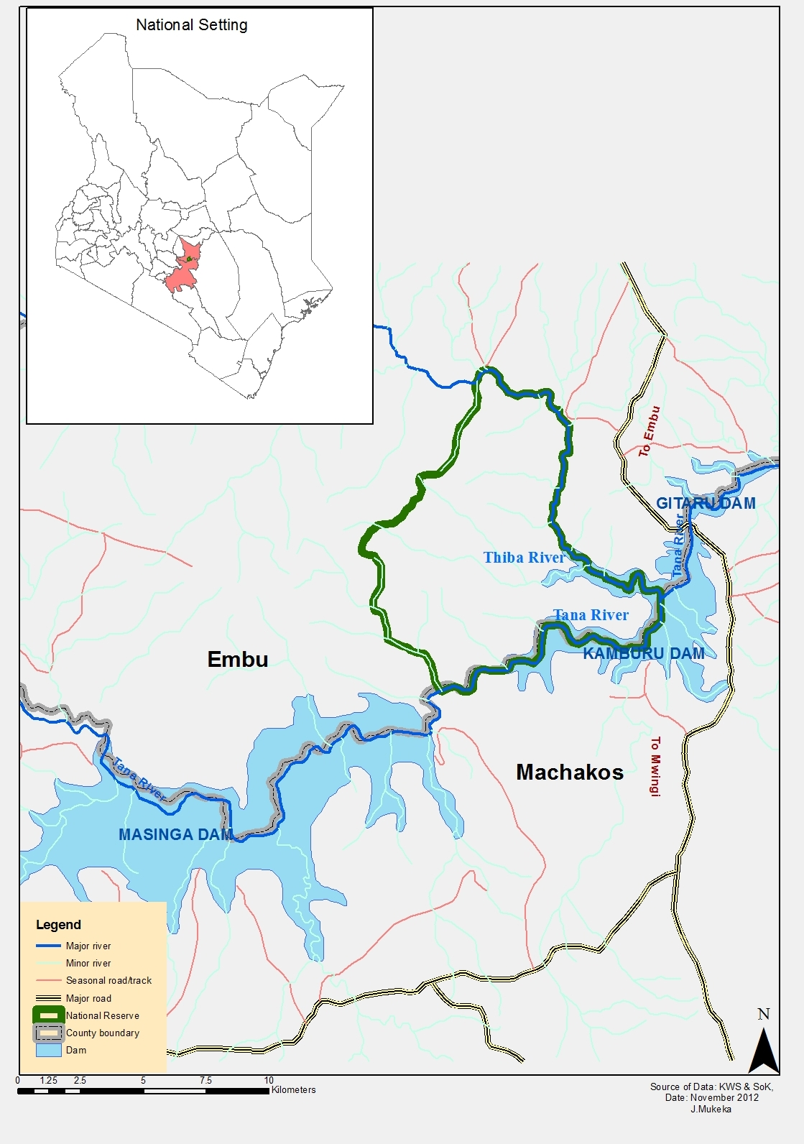

Figure 1: A location map forMNRin relation to its location in Kenya

Census Block

The aerial count followed the method described by Douglas-Hamilton (1996). One counting block of 42km² was used. Flight lines of one kilometer spacing were designed with the intention of ensuring that all elephant herds and large mammals were sighted and counted (Figure 2). In addition, search for hippos and crocodiles within the water bodies were undertaken. A total of 15 transects were flown inside the reserve representing a distance of about 50kilometers.

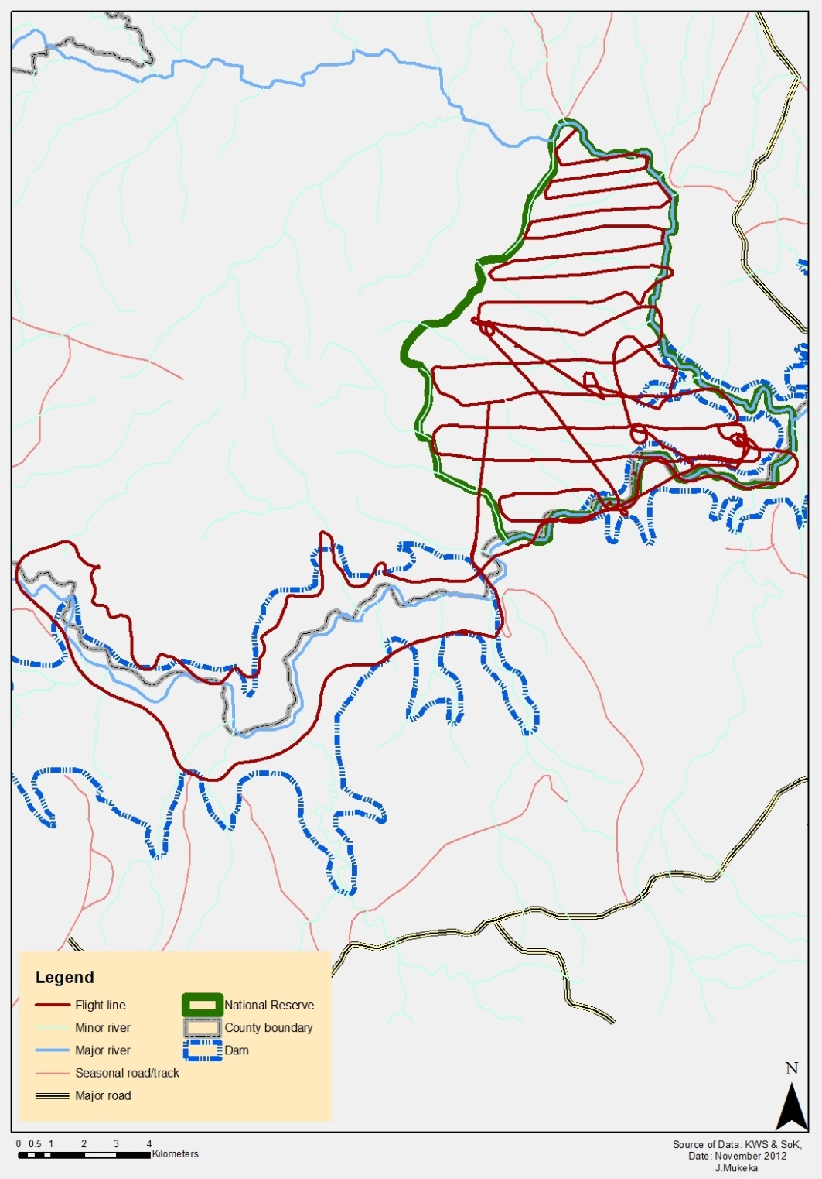

Figure 2: A map showing the flight lines used during the 26thSeptember 2012 MNR aerial survey of elephants and other large mammals. Circling ensured that herds were counted correctly while a recce along the Masinga dam was used to search for hippos and crocs in the area – a major source of human-wildlife conflict.

Aircraft and crew

A Bell 206 helicopter was used during the one day exercise. The crew comprised of a pilot, one front seat observer (FSO) and two rear seat observers (RSOs). The crew members were highly experienced in aerial count methods and endurance. A flight map of the counting block was made available to the team in the evening. This was to allow the crew to plan for the next day’s event. Navigation was aided by a hand held Geographical Positioning System (GPS)receiver provided to the crew. The GPS receiver was used by the FSO to record waypoints and log flight paths. The GPS were set to Universal Transverse Mercator (UTM) coordinate system to enable navigation with the gridded map. The crew took off in the morning (at around 7:00a.m). This was aimed at ensuring that counting started before the day temperatures were high. Parallel lines whose intervals were determined based on terrain and visibility were flown. The interval ranged between 0.5-2km as determined by the front seat observer and the pilot. The topography and vegetation cover influenced the flight paths as rugged terrain and very thick vegetation cover was avoided.

Data recording and cleaning

The aerial census took place on the 26th of September 2012. Test flights were conducted a day before the actual counting commenced to train the helicopter pilot and refresh the crew. The helicopter was flying at a speed of approximately 100-120 km/hr. Heights of about 200-400 feet above ground level were maintained as recommended by Douglas-Hamilton (1996). Data on both dead and live elephants were recorded. When large herds of elephants and other large mammals were sighted, the pilot circled around several times to give observers ample time to count the species (See annex 1 for data sheet used during the aerial count). The elephant carcasses were classified as ‘fresh’, ‘recent’, ‘old’ or ‘very old’ (Douglas-Hamilton and Hillman, 1981). For ease of analyses, the first and second categories were pooled together and referred to as “Recent” whereas thethird and fourth categories were grouped as “Old”. Other data recorded was on estimates of livestock and large mammal species. The counting crew used standard codes to denote various species as advised by Douglas-Hamilton (1996; See Annex 2). FSOs cleaned the data sheets when necessary before handing to the data entry team. Waypoints and tracks were downloaded on to ArcGIS 9.3. The tabulated species data was added onto the ArcGIS software and a spatial join created based on the way point (ESRI, 2010; Mitchell, 2009). The file was converted into a shape file for the block. FSOs cleaned the data sheets when necessary before handing them over to the data entry team.

Data analysis

The area covered was small and the different types of species were few and so were the numbers of individual species. Advanced analysis based on size of area as well as the numbers counted was not possible therefore. We used distribution maps to show herd sizes as well as display numbers on maps using graduated symbols and Jenks Natural Breaks classification scheme with three (where possible) classes was used (ESRI, 2010). Natural breaks are ideal for these data as they help to identify big jumps in the data and therefore would identify natural groupings of wildlife. No normalization was applied on the quantity parameter (Mitchelle, 2009).

We further used the non-parametric kernel density estimation (KDE) to create density surfaces that are good for visualizing how species densities vary over the study area (ESRI, 2010). KDE produces a smooth map that reflects the number of points in the surrounding area (Comaniciu, 2003; Hwang et al., (1994). KDE calculates a density surface based on a constant bandwidth with closer points being given more weight (Goldsmith, 1999). Percentage Volume Contours (PVC) at 95%, 90% and 50% were calculated for elephants and other species (Beyer, 2004). PVCs are used to depict visually where concentration of events occurs (Beyer, 2004).

Results

Census efforts and status of elephants and other mammals in MNR

The aerial survey of elephants lasted for about 1 hour of actual flying time. This represents a mean search rate of 42km² hour⁻¹. The reserve supports about 82 elephants and a corrected number of 90 animals representing an increase of about 76% in the last eighteen years. Table 1 below summarizes the results from the September 2012 and compares them with those of 1994 and 1995. Six sightings of elephants were made. One huge herd of 75 elephants, two groups of two individuals each and two isolated mature males were sighted (Table 1). The big group comprised a mixed herd (cow-calf and bulls) while the isolated individuals were all adult males. The total elephants counted constituted the minimum estimate this because a considerable number of calves below two years could have been overlooked during the count. No elephant carcasses were sighted during the count.

Other mammals counted included Cape buffalo (Synceruscaffer) , Rothschild’s giraffe ( Giraffacamelopardalisrotschildii) , Common zebra (Equusburchelli) Lesser kudu (Strepsicerosimberbis) , Bushbuck (Tragelaphusscriptus) , Waterbuck (Kobusellipsiprymnus) , Warthog ( Phacochoerusaethiopicus) and Impala (Aepycerosmelampus) ). Hippopotamus (Hippopotamus amphibious) and Crocodiles (Crocodilusniloticus) were also sighted outside the study area along the shores of Thiba and Tana rivers. Table 2 below provides a summary of the other large mammals sighted and counted during the aerial survey and other aerial surveys in 1994 and 1995.

Table 1: Summary of groups of elephants sighted during the aerial counted (September, 2012)
Sightings | No. of elephants
1 | 1
2 | 1
3 | 2
4 | 75
5 | 2
6 | 1
Total | 82

Table 2: Summary of other species sighted during the aerial survey (September, 2012)
Species | Number
Buffalo | 32
Giraffe | 11
Hippopotamus | 41
Lesser kudu | 2
Waterbuck | 2
Bushbuck | 14
Impala | 7
Common zebra | 81
Grey Duiker | 18
Dikdik | 5
Warthog | 4
Olive Baboon | 32
Crocodile | 19
Guinea fowl | 10

The distribution of elephants and other large mammals in MNR

The species sighted during the aerial survey occurred on the south eastern and central parts of the reserve (Figure 3). Most of the elephants (n=75) were sighted on the south eastern tip of the reserve next to Kamburu dam (Fiure 4). Figure 5 below shows the distribution of buffalo, giraffe, common zebra, bushbucks, lesser kudu, and duikers sighted during the survey. The distribution of other species is shown in figures 6 and 7 below. Hippotamus and crocodiles occurred within the rivers and dams in the study area (Figure 7).

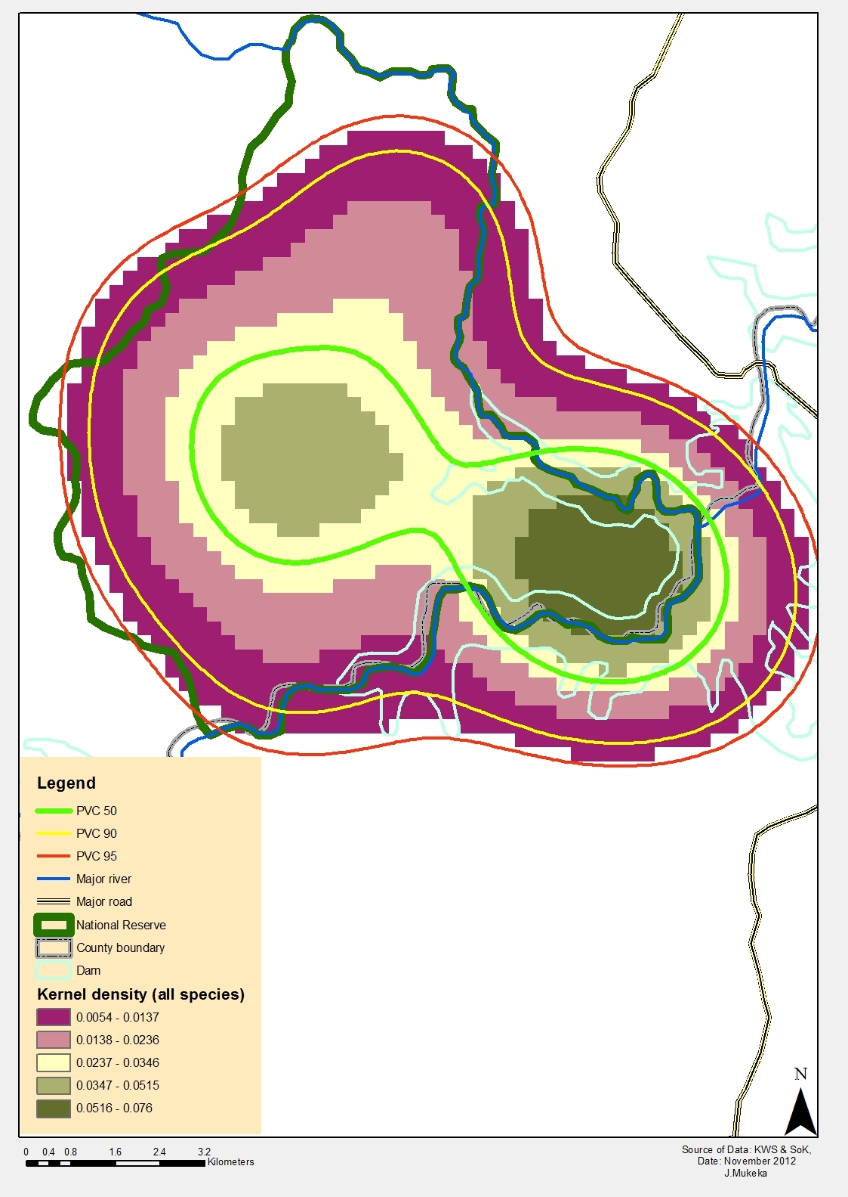

Figure 3: The kernal density and percentage volume contours (PVC) of all species counted in in MNR (September, 2012). Close to 90% of the wildlife habitat the MNR with 50% occupying the center most part of the reserve. Range as depicted by PVCs may not necessarily represent viable habitat though.

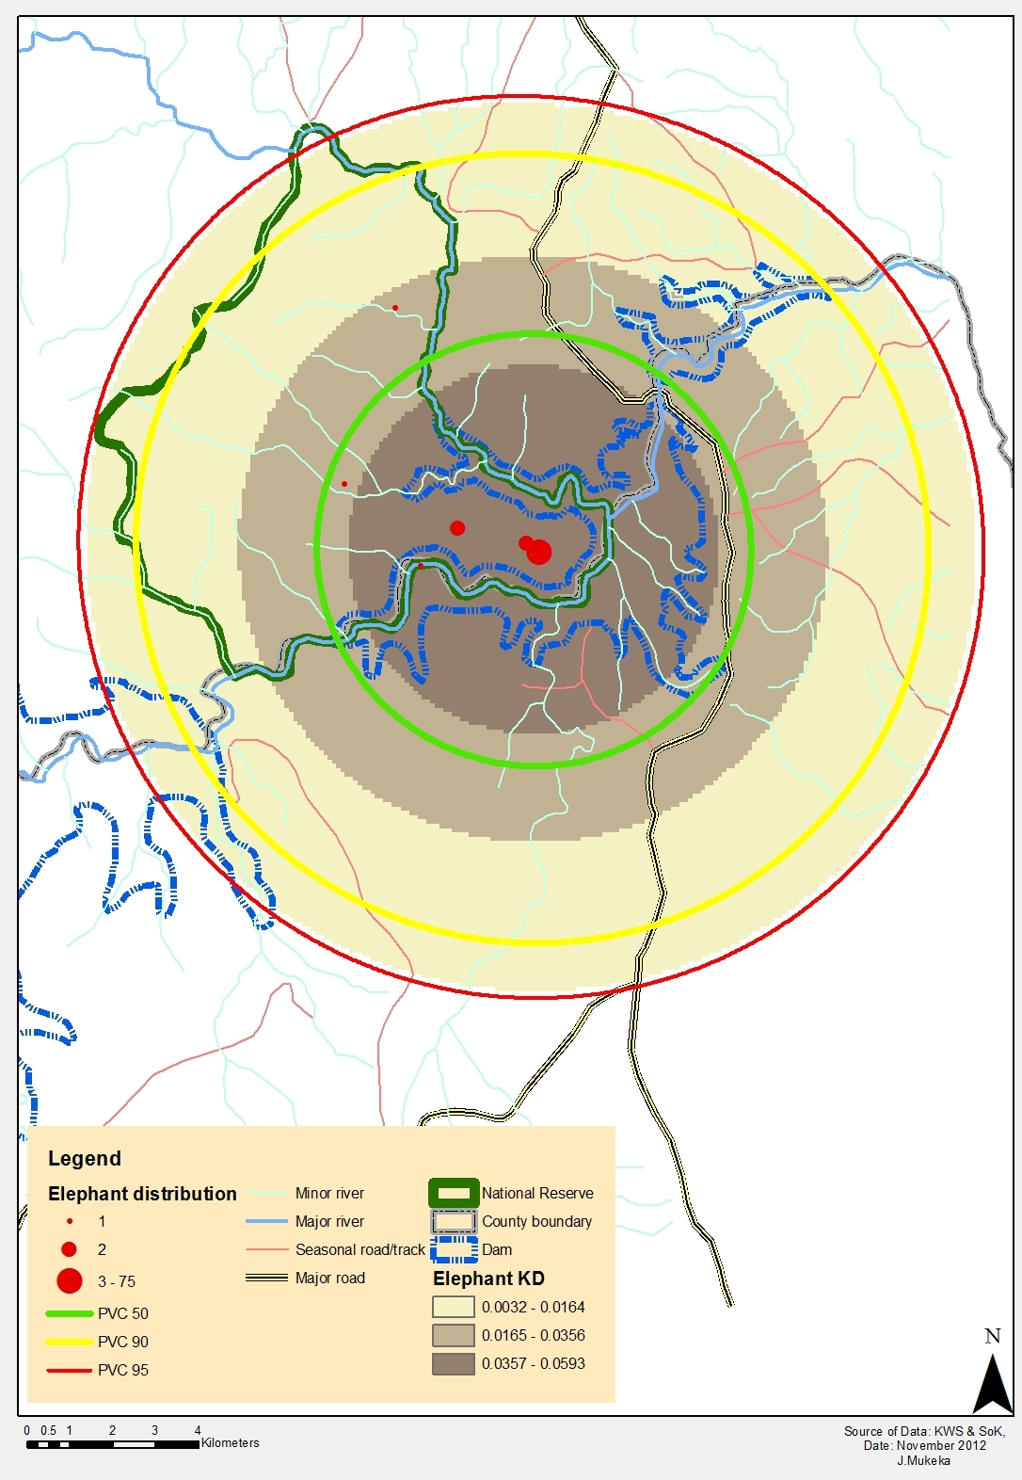

Figure 4: The distribution, kernal density and percentage volume contours (PVCs) of elephants in MNR (September, 2012). Elephants occupy the south eastern part of the reserve at the confluence of river Tana and Thiba.

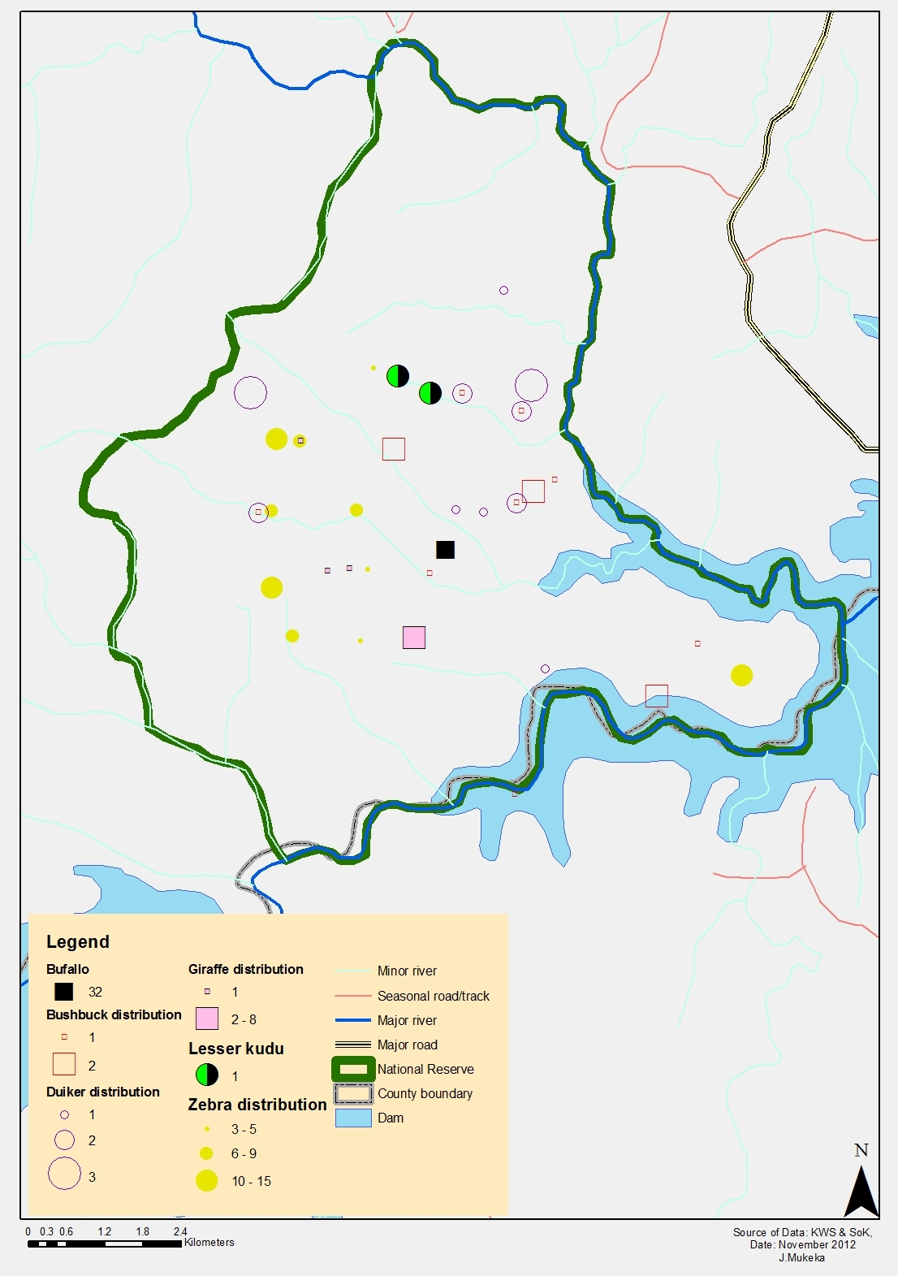

Figure 5: The distribution of bushbuck, giraffe, lesser kudu, duiker and zebra in MNR (September, 2012)

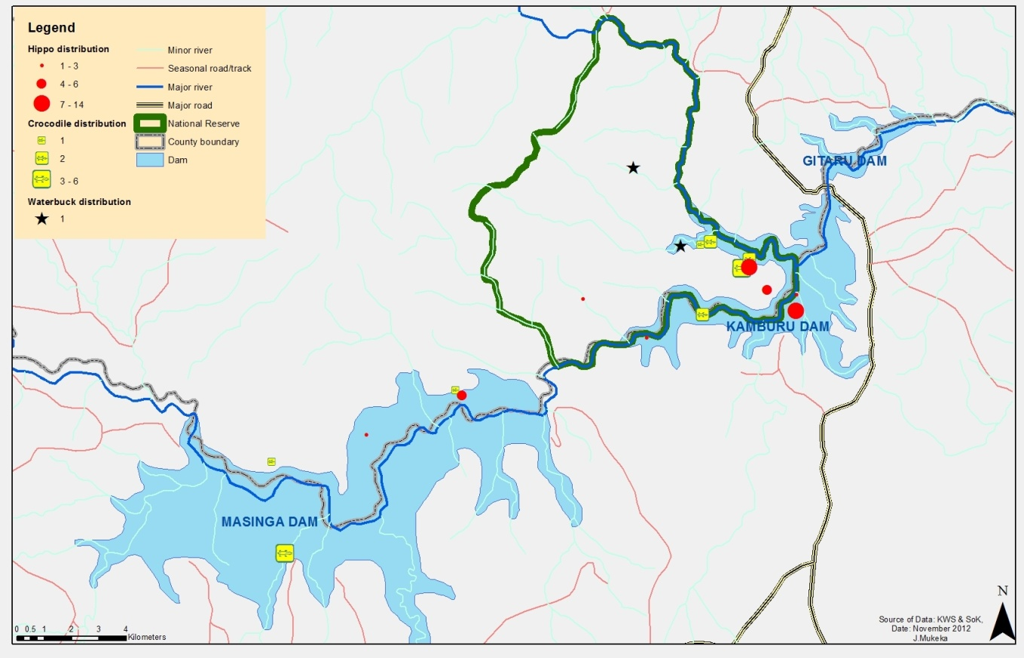
Figure 6: The distribution hippopotamus, crockdiles and waterbucks in Mwea National ReserveMNR (September, 2012).

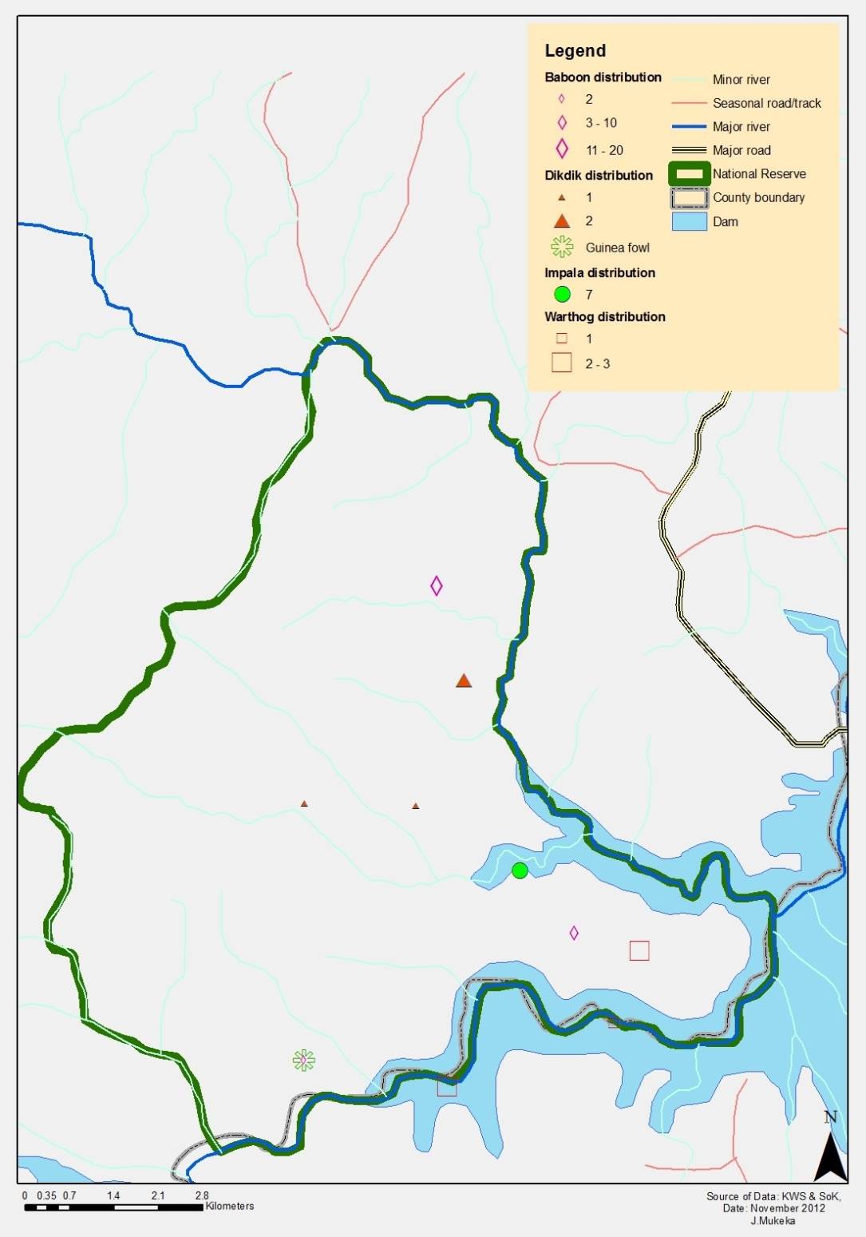
Figure 7: The distribution of baboons, dikdik, impala, and warthog in MNR (September, 2012)

Discussion

The survey established a minimum of 82 elephants. According to Norton-Griffiths (1978), total counts typically under-estimate the true numbers by a factor of 10%. However, this varies according to the time taken for the count, the skills of the observers and pilot, and the thickness of vegetation cover (Norton-Griffiths, 1978; Litoroh, 1995). Since the pilot used during the count was new and this was his first time to undertake an aerial survey, a correction factor of 10% was used. This translated to an estimate of about 90 elephants in the reserve. In addition to applying the correction factor, the count was done in September 2012 when most of the shrubs and trees had shed their leaves making sightings of wildlife easier. Litoroh (1994) used the 10% correction factor and recorded an estimate of 51 elephants in the reserve.

September 2012 aerial survey results divulged that the population of elephants in the reserve increased by about 76% (n=39; N=90) between 1994 and 2012. Table 4 below summarizes the trend of elephant population between 1978 and 2012. Assuming a mean annual increase of 4% (KWS Elephant Strategy, 2012) and that all factors remain the same, the 51 elephants in 1994 should have increased to about 103 elephants by 2012. It implies that certain factors were limiting the population growth. First, human encroachment reduced the reserve size from 68km² to about 42km² by 1996 (Njumbiet al., 1995). Such reductions in size resulted to increased human-elephant conflicts. Control shooting by KWS and at times, killing of elephants by farmers before the reserve was fenced could have resulted to the current observed population. For example, by 1995 KWS shot 4 bulls (Njumbiet al., 1995) and further 4 elephants by 2012 to mitigate human-elephant conflicts (KWS Database Security, 2012). Second, poaching could have further reduced the elephant population in the reserve. However, no elephant has been reported poached from the reserve between 1990 and 2012 (KWS Security Database, 2012). Third, death of elephants due to natural causes (droughts and diseases) also contributed to the recorded population. One elephants died due to natural cause between 1994 and 2012 (KWS Security Database, 2012). Fourth, 23 elephants were translocated from the reserve in 1996 (Litoroh, 2005). This left about 28 elephants in the reserve (Litoroh, 1995; Chira, 2005). The mean annual increase of natural elephant population is estimated at 7.5% (Jachmann, 1980). Assuming this mean annual increase, the population should have increased to about 89 animals after the 1996 translocation. Our results estimate about 90 elephants in the reserve, which confirms a natural population increase since 1996 (Jachmann, 1980). This is further supported by the fact that no elephant has been lost to poaching over the last 18 years (KWS Security Database, 2012). The reserve is the only protected area that has not been affected the upsurge of elephant poaching since 2008 (KWS Security Database, 2012). Electric fencing of the reserve in 1998 made it easier for management to provide security for elephants and other wildlife.

The survey estimated a density of about 2 elephants km⁻² in the reserve. Litoroh (2005), Njumbiet al. (1995), Musyoki and Manaengene (1998), and Chira (2005) estimated the elephant density in the reserve to be 1.2animals km⁻², 1.1animals km⁻², 1.3animals km⁻², 1-1.2animal km⁻² respectively. Only Chira (2005) researched on the impacts of elephants on woody plants in the reserve. The elephant density had not resulted to serious ecological change through vegetation destruction (Chira, 2005). They were responsible for about 20% impact on woody plants with 7% and 13% of the woody plants being seriously and slightly browsed by elephants respectively (Chira, 2005). However, with the current density of 2 animals’ km⁻², it is important to evaluate whether the elephants have started having a negative impact on the reserve’s vegetation through destruction of woody plants. A mean elephant density of 1.6animals km⁻² in Shimba Hills National Reserve was observed to have considerable impact on the vegetation (Mwathe, 1997; Hoft and Hoft, 1995). Negative impacts of high elephant density on woody vegetation was recorded in Amboseli ecosystem (Western, 1990), Aberdare National Park, Tsavo National Park, and Laikipia area (Waithaka, 1994), and other protected areas in Africa as outlined by Chira (2005).

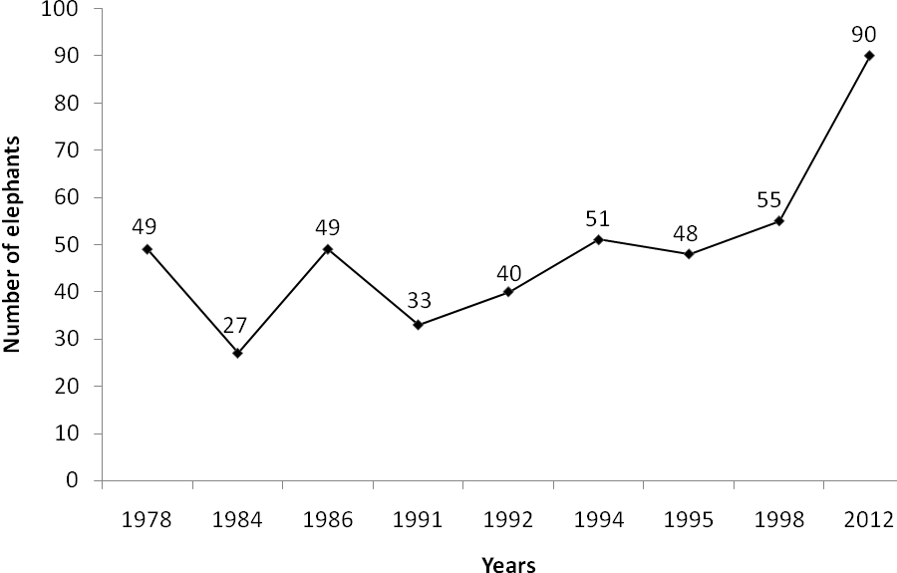

Figure 7: The population trend of elephants in MNR. [Source:Litoroh (1994); Chebures (1986 & 1989); KWS (1991); Poole et al. (1992); Njumbiet al.(1995); Musyoki and Manengene (1998); Thoulesset al. (2008); Blanc et al. (2007)]

Kenya Wildlife Service introduced 30 common zebras in the reserve in 2001 (Chira, 2005). Only 17 common zebra were recorded in the reserve in 2005 after 5 died and 8 escaped from the reserve due to lack of a suitable zebra habitat in the reserve (Chira, 2005). The sighting of 81 common zebra, representing a 376% (n = 64) increase is an indication that the population is doing well. Provision of water at the more open parts of the reserve as well as use of fire as an habitat management tool are expected to further result to their increase in coming years. The increasing population of zebras may result to competition with buffalo for forage as both species utilize the same habitats (Chira, 2005). There is need to understand the population dynamics of these two species to avoid such competitions in future.

Prior to the introduction of zebra into the reserve in 2001, KWS introduced nine Rothschild giraffes. This aimed to diversify species richness and increase attractiveness of the reserve to tourists (Chira, 2005). The population was doing well and increased to about 12 individuals in 2003 (Chira, 2005) and over 22 individuals in 2010 (Gathungupers. comm.). The low number sighted (n=11) in 2012 was due to death of about 11 giraffe in 2010 due to outbreak of anthrax in the reserve. Literature on occurrence of outbreaks of anthrax and foot and mouth disease in the reserve is scanty but it is believed past outbreaks as well as subsistence poaching could have resulted to low numbers of giraffe and other species sighted during the survey. It is important to monitor the population dynamics of the giraffe to avoid a future risk of intense competition for forage with elephants because their food requirements overlap (Chira, 2005).

Chira (2005) reported that lesser kudu were last sighted in the reserve in 1998. However, the September 2012 aerial survey sighted 2 lesser kudu. It is possible that these animals were still in the reserve but at very low numbers under thick vegetation cover, which made it difficult to sight them. This population can be increased by translocating more animals into the reserve.

Conclusion

The elephant population in MNR has continued to increase since 1994. The population increased by about 7.5% between 1996 and 2012. The survey recorded a minimum of 82 elephants but corrected this by 10% to yield about 90 elephants. This population translated to a density of about 2 elephants’ km⁻². Previous data on other species was scanty but this survey established minimum number of buffalo (n=32), zebra (n=81), and giraffe (n=11), a basis for comparison with future surveys. No elephant carcasses were sighted during the survey. We suggest that tri-yearly aerial survey in the reserve should be initiated. The next aerial survey should be undertaken in September 2015.

Recommendations

The following is recommended:

- To manage the genetic diversity of the populations, there is need to translocate (in or out?) more elephants, common zebra, buffalo, and giraffe to reduce changes of genetic drift due to inbreeding.
- Aerial counts should be undertaken after every three years to establish the rate of species population change.
- There is need to establish the current impact of elephants on woody plants in the reserve as their current density is high (about 2 elephants km⁻²)
- Introduce locally extinct species (e.g., kongoni and black rhinoceros) in the reserve
- There is need to establish the carrying capacity of elephants of the reserve
- Use of fire as an habitat management tool should be enhanced through development of a reserve fire management plan
- The reserve’s management plan needs to be revised to guide its management

Acknowledgements

We acknowledge the support from Kenya Wildlife Servicefor approving implementation of this project. Special thanks go to the Deputy Director – Biodiversity Research and Monitoring Division and the Acting Assistant Director – Mountain Conservation Area (AggreyMaumo) for their support during the planning and execution of the aerial survey. The warden MNR(Wellington Gathungu) is acknowledged for his administrative and logistics support during the survey.We appreciate the entire staff of the MNR for their support during the aerial survey.

References

Barnes, R.W. (2001) How reliable are dung counts for estimating elephant numbers?African Journal of ecology 39: 1-9.

Barnes, R.F.W. and Jansen, K.L. (1987) How to count elephants in the forest.African Elephant and Rhino Specialist Group. Technical Bulletin 1: Causeway, Zimbambwe.

Bear, L.M.(1952) A geological reconnaissance of the area South East of Embu(with coloured geological Map). Explanation of degree sheet 44, SE quadrat report No. 23 Survey of Kenya, Nairobi,Kenya.

Caughley, G. (1976) Plant-herbivore systems: In: Theoretical Ecology; principles and applications (ed. R.M. saunders). Philadelphia, Pennyslyvania, USA.

Chebures, B.J. (1986) A reconnaissance Survey of MNR Ecology. A report to Wildlife Conservation and Management Department (WCMD), Nairobi, Kenya.

Chebures, B.J. (1989) Mwea National Park management Plan. Wildlife Conservation and Management Department, Nairobi, Kenya.

Chira, R.M. (2005) The role of elephants in habitat dynamics and its effects on other mammalian species in Mwea National Park. PhD thesis, university of Nairobi, Nairobi, Kenya.

Comaniciu, D., Ramesh, V. and Meer, P. (2003) “Kernel-Based Objects Tracking.”IEEE Transactions on Pattern Analysis and Machine Intelligence, Vol. 25, no. 5.

Darling, F.F. (1960) Wildlife in African Territory. Oxford University Press, London.

Douglas-Hamilton, I. and Hillman, A.K. (1981) Elephant carcasses and skeletons as indicators of population trends in Low-level aerial survey techniques. ILCA Monograph

Douglas-Hamilton, I. (1996) Counting elephants from the air: total counts. In: Kangawana, K.F. (ed.), Studying Elephants. AWF Technical Handbook Series Vol. 7.pp.28-37. Nairobi: African Wildlife Foundation.

ESRI. (2010) ArcGIS Desktop: Tools for authoring, editing, and analyzing geographic information. Redlands, CA: ESRI Press.

Field, C.R. (1971) Elephant ecology in the Queen Elizabeth national Park, uganda. E. Afri. Wildl. J.9: 99-123.

Gachago, S. (1995) The Kiambere elephant population. Nairobi: Kenya Wildlife Service Elephant
Programme.

Goldsmith V. (1999) Analyzing Crime Patterns.Thousand Oaks, CA: Sage Publications

Harrington, G.N. and Ross, I.C. (1974)The Savanna ecology of kidepo Valley National Park,Uganda. Effects of burning and browsing on the vegetation. E. Afr. Wildl. J.,12:93-105.

Hoft, R. and Hoft, M. (1995) The differential effects of elephants on rain forest communities in shimba Hills, Kenya. Biol. Conser. 73: 67-70.

Hwang, J., Lay, S. and Lippman (1994). “Nonparametric multivariate density estimation: a comparative study”, IEEE Trans. Signal Processing, Vol. 42.

Jachmann, H. (1980) Population dynamics of the elephants in Kasungu National Park, Malawi. Netherlands Journal of Zoology, 30, 622–634.

KWS Security Database(2012) elephant mortality in Kenya. A database at Kenya Wildlife Service, Nairobi, Kenya.

KWS Elephant Strategy (2012) A strategy for the conservation and management of elephants in Kenya.A KWS report, Nairobi, Kenya.

KWS (1991) Elephant Conservation Plan, Kenya.Kenya Wildlife Service, Nairobi, Kenya.

Lamprey, H.F., Glover, P.E., Turner, M. and Bell, R.H.V. (1979) Invasion of the Serengeti National Park by elephants. E. Afri. Wildl. J.5: 151-166.

Laws, R.M.(1969) The Tsavo research project.J. Repro. Fert. Suppl.6: 495-531.

Laws, R.M. (1970) Elephant as agents of habitat and landscape change in East Africa. Oikos21: 1-5.

Litoroh, M.W. (1994) Aerial census of elephants in MNR.A report to Kenya wildlife Service, Nairobi, Kenya.

Mitchell, A. (2009)The ESRI guide to GIS analysis: Volume 2, spatial measurements and statistics. ESRI Press, Ridland, California, USA.

Mwathe, K.M. (1997) Elephant-habitat interactions in Shimba Hills National Reserve. In: Shimba Hills elephant management workshop. An unpublished report to Kenya Wildlife Service, Nairobi, Kenya.

Njumbi, J.S., Gachago, S.W. and Waithaka, J. (1995) Population dynamics of the MNR Elephants. A Report to KWS Elephant Programme, Nairobi, Kenya.

Norton-Griffiths, M. (1978) Counting animals, 2nd edition.African Wildlife Leadership Foundation, Nairobi, Kenya.

Poole, J.H., Aggarwal, N., Sinange, R., Ng’ang’a, S., Broten, M. and douglas-Hamilton, I. (1992) The status of Kenya Elephants. A report by Kenya Wildlife Service and Kenya Resource Surveys and Remote Sensing.European Union, Nairobi, Kenya.

Thouless, C.R., King, J., Omondi, P., Kahumbu, P. & Douglas, I. (2008)The status of Kenya’s elephants: 1990-2002. Kenya wildlife Service and Save the Elephant, Nairobi, Kenya.

Van de Weg, R.F. and Mbuvi, P.J. (1975) Soil of the Kindaruma area. Kenya Soil Survey R1, Nairobi,Kenya.

Waithaka, J.M. (1994) The ecological role of elephants in restructuring plants and animal communities in different eco-climatic zones in Kenya and their impact on land-use practices. Ph.D thesis, Kenyatta University, Nairobi, Kenya.

Western, D. (1989) Why manage nature? In: Conservation for the 21st century (Western d. and M.C. Pearl eds.) New York: Oxford University Press.

ANNEXES

Annex 1: The MNRtotal aerial census data Sheet used on 26 September 2012

 |  |  |  |  |  |  |  | SHEET NO.
Pilot |  |  |  |  |  |  | Block No.
Front Seat Observer
Rear Seat Observer(left) |  |  |  |  |  |  | Date
Rear Seat Observer(right)
Take off |  | Start count |  |  | Stop count |  | Land
Time |  | Time |  |  | Time |  | Time
Way | Approx | L/R | Species | Estimate | Frames | End | Photo- | Comments
Point No. | Dist. (M) |  |  |  |  | Frame | count | (Keep approx time)
 |  |  |  |  | Mem card ID

Annex 2: Species codes used in recording data

CODE | SPECIES
BN | Baboon
BF | Buffalo
BB | Bushbuck
CH | Cheetah
CM | Colobus monkey
CC | Crown cranes
DD | Dikdik
DK | Duicker
ED | Eland
EL | Elephant
F | Elephant carcass fresh
O | Elephant carcass old
R | Elephant carcass recent
VO | Elephant carcass very old
FE | Fish eagle
FX | Fox
GN | Gerenuk
GR | Giraffe
GG | Grants gazelle
HP | Hippo
HR | Hirola
HY | Hyaena
IM | Impala
JK | Jackal
KL | Klipspringer
KG | Kongoni/Hartebeest
KB | Kori bustard
LK | Lesser kudu
LN | Lion
OX | Oryx
OS | Ostrich
RB | Reedbuck
SC | Secretary bird
TG | Thomson gazelle
TP | Topi
VM | Vervet monkey
WH | Warthog
WB | Waterbuck
WD | Wild dog
WL | Wildebeest
ZB | Zebra Common
ZG | Zebra Grevy

Annex 3:A herd of elephants sighted during the September 2012 MNRtotal aerial count of elephant and other large mammals

