Aerial census of elephants and other mammals in Shimba Hills, Mkongani, and Mwaluganje Conservation Areas

Shadrack Ngene^{1*}; Joseph Mukeka²

¹Kenya Wildlife Service, Biodiversity Research and Monitoring, Species Conservation and Management, P.O. Box 40241-00100, Nairobi, Kenya; ²Kenya Wildlife Service, Biodiversity Research and Monitoring, Geographic Information Systems (GIS) Section, P.O. Box 40241-00100, Nairobi, Kenya

*Corresponding Author: Shadrack Ngene; E-mail: sngene@kws.go.ke or ngene@itc.nl

Abstract

This paper updates the population of elephants and other mammals in Shimba Hills Conservation Areas. Data was acquired through aerial survey of the conservation areas using a Bell 206 helicopter. The helicopter was flown along transects of 1km spacing at an altitude of 200-400 feet above the ground and speed of approximately 100-120km hr⁻¹. An area of about 255km² was covered during the aerial census. The aerial census lasted for about 4hour and 35minutes of actual flying time. This represented a mean search rate of 56.7km² hour⁻¹. A minimum total of 274 elephants were recorded during the census. This translates to a density of approximately 0.90animals km⁻². Once a correction factor of 0.1 is applied, the number increases to 301animals, translating to a density of about 0.80animals km⁻². Thirty nine elephant sightings (159 in block 1 and 115 in block 2) were made with larger elephant herds being counted in block two than in block 1. Based on a ±95% confidence interval, the herd sizes of elephants varied from 3-6 and 2-10 in blocks 1 and 2 respectively. A total of 23 elephant carcasses (recent = 3; old = 13; very old = 7) were sighted. Six and seventeen carcasses were sighted in block 1 and block 2 respectively with all the recent carcasses being in block 1.

Key words: Aerial census, Conservation Areas, Shimba Hills, Mwaluganje, Mkongani, Forests

Introduction

The Shimba Hills Conservation Areas consists of the Shimba Hills National Reserve, Mkongani (west and north) Forest Reserves and Mwalunganje Elephant Sanctuary. These conservation areas are home to the remaining population of elephants in Kwale County. Before the elephants were confined to the conservation areas, they used to roam freely within the Kwale County (Estes, 1970). Before 1961, these elephants were part of a larger population that ranged across the entire Kwale County and as far as Tsavo and Mkomazi, which are about 60km north and 40km south respectively (Estes, 1970). Large herds of over 10,000 elephants annually migrated every October and November from the south to the east of the conservation areas in search of palm seeds (Thouless et al., 2008). The elephants were however gradually eliminated from the rest of the county through controlled shooting and later through human settlements and poaching (Thouless et al., 2008). For example, between 1961 and 1962, about 250 elephants were shot in the area to create the Shimba Settlement Scheme (Estes, 1970).

After the establishment of the settlement scheme, human population continued to increase. This was followed by a wave of poaching in 1970s and 1980s. Poaching forced the remaining elephants to be confined in the conservation areas for protection (Thouless et al., 2008). At the same time, human-elephant conflicts started to be experienced in the area as human population and area under farms increased. To resolve the conflicts, the conservation areas within the Shimba Hills were fenced with electric fence between 1991 and 1995 (Thouless et al., 2008; KWS, 2012). Fencing resulted to insularization of elephants within the conservation areas. The insularization was a threat to the woody vegetation as elephants at higher densities started to destroy them (Ross, 1984). As a result, it became necessary to constantly monitor the Shimba Hills Conservation Areas’ elephant population.

The monitoring of elephant population in Shimba Hills has followed three main methods, which include dung count (Reuling et al., 1992; Mwathe, 1995; Omondi, et al., 1998), aerial count (Kiiru, 1995; Kahumbu, 1997; Litoroh, 1997; Tamooh, 2009; Kimtai, 2007) and individual recognition (Kahumbu, 2002) methods. Thouless et al. (2008) provides a summary of the elephant population status in the Shimba Hills conservation Areas. Using the dung count method, Reuling et al. (1992), Mwathe (1995), Omondi et al. (1998) and Litoroh (2002a) estimated about 429±128 animals, 453±181 animals, 598 animals, and 649±151 animals respectively in the conservation areas. Kahumbu (1995), Litoroh (1995), and Kimutai (2007) using a helicopter sighted a minimum of about 467 and 305 elephants in the conservation areas. However, Kahumbu (2002) estimated 658 animals using the individual recognition method after removal of 30 bulls from the conservation areas (Muir, 2000). In 1995 and 2009, about 232 and 144 elephants were sighted in the conservation areas using a fixed wing (Kiiru, 1995; Tamooh, 2009). The use of different methods to count elephants in the conservation area makes comparison of the results difficult. This paper compares results of aerial counts done using a helicopter only.

The goal of the aerial survey was to update the population status of elephants and other mammals in the Shimba Hills Conservation Areas and compare the results with those of 2007 (Kimutai, 2007). The specific objectives of the aerial census were to: establish the number and distribution of elephant and other mammals in the Shimba Hills conservation areas; establish the number and distribution of elephant carcasses; and, establish the distribution of logging sites in the conservation areas. It is important to continue monitoring elephants and other large mammals’ population in the insuralized Shimba Hills Conservation Areas. The data and information obtained will illustrate the number and distribution of elephants and other large mammals in the conservation areas. This information is important to conservation area managers and policy makers as it will guide them in making decisions regarding future management of elephants and other large mammals in the conservation areas in Shimba Hills.

Materials and Methods

Study area

The Shimba Hills, Mkongani and Mwalungaje Conservation Areas are located in Kwale County, which is approximately 40km south of Mombasa (Reuling et al., 1992). Shimba Hills was first gazetted as a National Forest in 1903. In 1967, the area of about 241km² was gazette as a national reserve and put under the joint management of the then Wildlife Conservation and Management Department [now Kenya Wildlife Service (KWS)] and the Forest Department [now Kenya Forestry Service (KFS)] (Thouless et al., 2008). Today, the reserve is still co-managed by both Kenya KWS and KFS. The Mwalugaje Forest Reserve, which is approximately 10km to the north of Shimba Hills Reserve below the escarpment, was gazette in 1941 (Thouless et al., 2008). It covers about 17km² and is connected to Shimba Hills Reserve by the 36km² Mwaluganje Elephant Sanctuary (Thouless et al., 2008).

The elephant sanctuary is a community-owned conservation area. The sanctuary was formed in the early 1990s as a cooperative project between the people of the surrounding Mwaluganje community, United States Agency for International Development, and the Born Free Foundation and the Eden Wildlife Trust. The sanctuary is an example of ecotourism, as well as community-based-conservation efforts, both of which are very recent trends in conservation management. In this community-based program, the local people have leased their privately-owned property to a community based trust. The trust manages the sanctuary for the conservation and preservation of the elephants. In addition, it is a source of revenue for the local people, through funds generated by eco-tourism and gate entrance fees. The area is off the Shimba Hills escarpment in Kwale District and is along the migratory route leading to Tsavo East National Reserve from Shimba Hills (http://en.wikipedia.org/wiki/Mwaluganje_Elephant_Sanctuary). Two smaller areas to the west of Shimba Hills Reserve that are almost entirely forested remain as Forest Reserves. These include Mkongani North and Mkongani West Forest Reserve (Omondi et al., 1994).

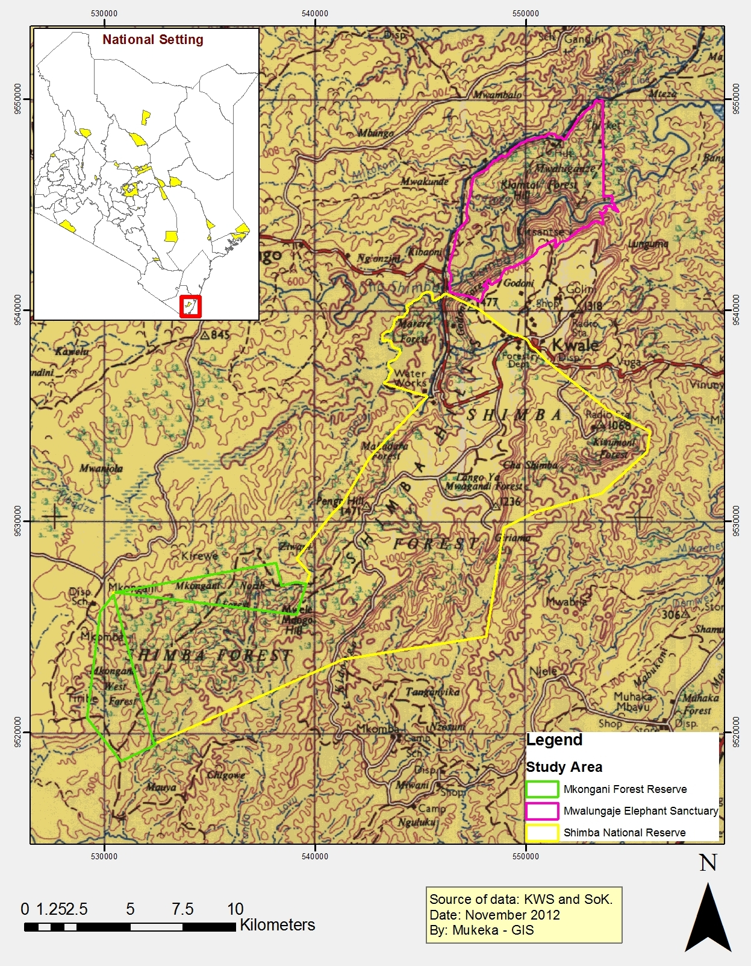

Figure 1: The location of Shimba Hills National Reserve, Mkongani Forest Reserve and Mwaluganje Elephant Sanctuary
The Shimba Hills are dissected plateaus that ascend steeply from the coastal plains. The surrounding escarpment rises from around 120m to 300m across the bulk of the plateau and as high as 450m at Marare and Pengo Hills. Small Rivers, some of which are seasonal, flow within sharply dissected valleys. The permanent Rivers supply fresh water to Mombasa and the Diani/Ukunda area. The plateau is entirely covered with sedimentary materials. The underlying rocks are the Triassic Shimba Grits, which mainly yields coarse grained ferratic acrisols. The Pliocene Magarini sands occur at the north central part near Kwale town. The sand are medium grained and have a higher cation exchange capacity.

Due to high altitude, the climate of Shimba Hills is hot and moist. However, it is cooler than other areas at the coast due to strong sea breezes and frequent mist and cloud in early morning. The mean annual temperature is about 24⁰C (Reuling et al., 1992). The hottest months are January and February while the coldest months are July and August. The area experience bimodal rain with long rains between April and July and short rains between October and December. The average annual rainfall is approximately 1,150mm (Omondi et al., 1994). Due to suitable rains that support crop farming, the areas around the reserve and sanctuary were settled by farming communities from early 1960s.

The north eastern to eastern, southern, western and north western boundaries are occupied by farming communities. These communities grow crops that include maize, bananas, oranges, coconut, and mangoes among others (Kahumbu, 2002; Reuling et al., 1992). To mitigate the human-wildlife conflicts, the conservation areas were fenced between 1991 and 1998 (KWS, 2012). The human settlements around the conservation areas together with electric fencing to protect crops have resulted to confinement of elephants to the conservation areas (Thouless et al., 2008). This compression has resulted in vegetation damage in some areas within the conservation areas (Kahumbu, 2002). Efforts to reduce the population of elephants in the conservation areas through translocation were implemented in 1995 and 1996 when over 200 elephants were moved from the conservation areas (Muir, 2000; KWS, 1997).

Apart from elephants other large mammals in the conservation areas include buffalo, sable antelope, and giraffe. Other mammals include warthogs, bushbuck, suni, baboons, and kongoni (Reuling et al., 1992; Omondi et al., 1998). The conservation areas are rich in plant diversity (Adanje, 1994). Detailed descriptions of plant composition and diversity are outlined by Chesire et al. (2012), Omondi et al. (1994) and Adanje (1994).

Census Block

The aerial census of elephants and other large mammals was undertaken as outlined by Douglas-Hamilton (1996). Two blocks were used during the census. Block 1 included the Shimba Hills National Reserve and Mkongani Forest Reserve, both with an area of about 218km². Block 2 consisted of Mwaluganje Elephant Sanctuary with an area of approximately 37km². Flight lines of 1km spacing were designed in each block to ensure that all herds of elephant and other large mammals were sighted and counted (Figure 2).
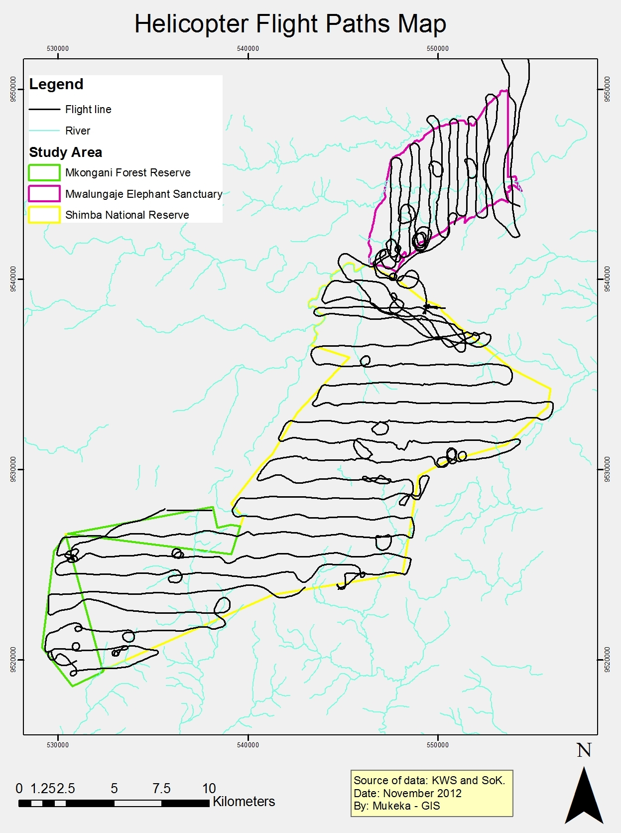

Figure 2: Flight lines used during the 17-19 July 2012 Shimba Hills Conservation Areas aerial census of elephants and other large mammals

Aircraft and crew

A bell 206 helicopter was used during the aerial census. The crew consisted of a pilot, one front seat observer (FSO) and two rear seat observers (RSOs). Apart from the pilot who was doing the aerial census for the first time, the rest of the crew members (RSOs and FSO) were highly experienced in aerial census methods and endurance. A team was assigned a block each evening. The team was provided with a flight map of the counting block to allow the crew to plan for the next day event. A Geographical Positioning System (GPS) unit provided to crew aided in navigation during the census. The FSO used the GPS unit to record waypoints of sighted elephants and other large mammals as well as flight paths. The GPS were set to Universal Transverse Mercator (UTM) kilometer grids on both north and south axis. The crew took off in the morning (at around 7:00a.m) but due to heavy rains during the census, the teams were delayed up to late morning (11:00a.m.) and early afternoon (14:30p.m.). Since the temperatures were low due to clouds cover, starting the count at these hours did not interfere with the daily activity patterns of elephants and other large mammals, therefore minimal bias were expected. Parallel lines whose intervals were determined based on terrain and visibility were flown. The interval ranged between 0.5-1km as determined by the front seat observer and the pilot. Topography and vegetation cover influenced the flight paths as rugged terrain and very thick vegetation cover was avoided.

Data recording and cleaning

The aerial census took place on 18 July 2012 and 19 July 2012. Test flights were conducted on 17 July 2012 to train the helicopter pilot and refresh the crew. The helicopter was flying at a speed of approximately 100-120 km hr⁻¹. During the census, the helicopter flew at heights of approximately 200-400 feet above ground level as recommended by Douglas-Hamilton (1996). Data on both dead and live elephants as well as other sighted large mammals were recorded. When large herds of elephants and other large mammals were sighted, the pilot circled around the herds several times. This was to enable the observers to have adequate time to count the individuals as well as agree on the actual numbers to be recorded on the data sheet (See annex 1 for data sheet used during the aerial count). Data on elephant carcasses were also collected. The sighted elephant carcasses were classified as ‘fresh’, ‘recent’, ‘old’ or ‘very old’ (Douglas-Hamilton and Hillman, 1981). For ease of analyses, the first and second categories were pooled together and referred to as “Recent” whereas the third and fourth categories were grouped as “Old” (Douglas-Hamilton, 1996). Other data recorded were on estimates of livestock and other large mammals. The counting crew used standard codes to denote various species as advised by Douglas-Hamilton (1996; See Annex 2). The FSO cleaned the data sheets before handing them over to the data entry team. Waypoints and tracks stored in the GPS were downloaded on to ArcGIS 9.10 (ESRI, 2010). The tabulated species data was added onto the ArcGIS software (ESRI, 2010). A spatial join was created based on the downloaded way point (ESRI, 2010; Mitchell, 2009). The file was then converted into a shape file for each block. The data was further checked for duplicates at zones of block overlap. Any double counts were appropriately corrected before merging all datasets into one.

Data analysis

A correction factor of 0.1 (10%) was applied to the total number of elephants sighted. This is because the study area had some parts with thick vegetation and in such areas total counts under-estimate the true numbers by about 10% (Norton-Griffiths, 1978). A ±95% confidence interval was used to discern the range of elephant herd sizes (Statsoft, 1996). Chi-square analysis was used to establish whether the observed and expected number of elephants counted in different years varied significantly (Zar, 1984). The analysis was performed using Statistica software (Statsoft, 1996). We used distribution maps to show herd sizes as well as display numbers on maps using graduated symbols and Jenks Natural Breaks classification scheme with three classes was used (ESRI, 2010). Natural breaks are ideal for these data as they help to identify big jumps in the data and therefore would identify natural groupings of wildlife. No normalization was applied on the quantity parameter (Mitchelle, 2009).

Non-parametric kernel density estimation (KDE) was used to create density surfaces. The density surfaces are good for visualizing how species densities vary over the study area (ESRI, 2010). KDE produces a smooth map that reflects the number of points in the surrounding area (Comaniciu, 2003; Hwang et al., (1994). KDE calculates a density surface based on a constant bandwidth with closer points being given more weight (Goldsmith, 1999).

Results

Census efforts, status of elephants, elephant carcasses and other mammals in Shimba Hills Conservation Areas

The aerial census lasted for about 4hour and 35minutes of actual flying time. This represented a mean search rate of 56.7km² hour⁻¹. The conservation areas support a minimum of 274 elephant, which represents a density of about 1.0animals km⁻². Once a correction factor of 0.1 is applied, the number increases to 301animals, translating to a density of 1.2animals km⁻². The population decreased by about 10% (n = 34 animals) since 2007 when the last helicopter count was done in the conservation areas (2007: n = 305; corrected n = 335). However, the number of elephants in the conservation area was not significantly different from that recorded in 2007 (Χ² = 1.70; df = 1; p = 0.20). Thirty nine elephant sightings (26 sightings: n = 159 in block 1; and, 13 sightings: n = 115 in block 2) were made during the census. Larger elephant herds were counted in block two than in block 1. Table 1 below summarizes herd sizes of elephants sighted during the aerial census. The ±95% confidence interval of the herd sizes were 3-6 and 2-10 in blocks 1 and 2 respectively.

A total of 23 elephant carcasses (recent = 3; old = 13; very old = 7) were sighted during the census. Out of the 23 carcasses, 6 and 17 were in block 1 and block 2 respectively. All the recent carcasses were in block 1. Table 2 presents a summary of the number of elephant carcasses counted during the census.

During the census, six different sightings of sable antelopes with a recording of 34 elephants were made. Five of the sightings were made in Shimba Hills National Reserve while one sighting was in Mwaluganje Elephant Sanctuary (Table 3). Other mammals counted included buffalo, warthog, waterbuck, bushbuck, baboons, Columbus monkeys, giraffe, kongoni and suni. Table 3 below provides a summary of the other mammals counted during the aerial census. Ten and two species of other mammals were recorded in blocks 1 and 2 respectively (Table 3).

Table 1: Different sightings of elephant herds in the Shimba Hills Conservation Areas (July, 2012)

Sightings | Block 1: Shimba Hills/Mkongani Forest Reserve | Block 2: Mwaluganje
1 | 2 | 7
2 | 3 | 15
3 | 2 | 2
4 | 8 | 20
5 | 4 | 2
6 | 1 | 5
7 | 5 | 15
8 | 3 | 50
9 | 5 | 9
10 | 3 | 6
11 | 4 | 2
12 | 6 | 14
13 | 5 | 12
14 | 2 | 0
15 | 11 | 0
16 | 4 | 0
17 | 1 | 0
18 | 10 | 0
19 | 1 | 0
20 | 3 | 0
21 | 2 | 0
22 | 2 | 0
23 | 19 | 0
24 | 2 | 0
25 | 1 | 0
26 | 6 | 0
Total | 115 | 159
Density | 0.5 elephants km⁻² | 4.3 elephants km⁻²

Table 2: A summary of elephant carcasses counted during the aerial census in Shimba Hills Conservation Areas (July, 2012)

Elephant carcasses | Block 1 | Block 2 | Total
Recent | 3 | 0 | 3
Old | 2 | 11 | 13
Very old | 1 | 6 | 7
Total | 6 | 17 | 23

Table 3: A summary of other mammals counted during the aerial census in Shimba Hills Conservation Areas (July, 2012)

Species | Number of animals
 | Block 1 | Block 2 | Total
Buffalo | 67 | 0 | 67
Warthog | 52 | 29 | 81
Sable antelope | 33 | 1 | 34
Waterbuck | 9 | 0 | 9
Bushbuck | 2 | 0 | 2
Baboon | 7 | 0 | 7
Colombus monkey | 2 | 0 | 2
Giraffe | 3 | 0 | 3
Kongoni | 4 | 0 | 4
Suni | 1 | 0 | 1

The distribution of elephants, elephant density, and elephant carcasses, and other mammals in Shimba Hills Conservation Areas

The elephants were located at Mwaluganje Elephant Sanctuary, Shimba Hills National Reserve, and Mkongani West Forest Reserve. At Mwalunganje, the elephants occurred within the central and southern parts of the sanctuary whereas in Shimba Hills, they occurred in the north, central, eastern, south eastern and south western parts of the reserve (Figure 3). In Mkongani Forest Reserve, the elephants were sighted on the north and south of the reserve (Figure 3). The highest elephant density (≥ 0.70) was recorded in central to southern parts of Mwaluganje Elephant Sanctuary and a small portion at the north of Shimba Hills National Reserve (Figure 4).

During the aerial census, a total of 22 sightings of elephant carcasses were made. About 73% (n = 16) and 27% (n = 6) of the sighted elephant carcasses were in Mwaluganje Elephant Sanctuary and Shimba Hills National Reserve respectively. Figure 5 below shows the distribution of different categories of elephant carcasses in the conservation areas.

About 83% (n = 5) and 17% (n = 1) of sable antelope sightings were recorded in Shimba Hills National Reserve and Maluganje Elephant Sanctuary respectively (Figure 6). All the buffalo, waterbuck, bushbuck, baboons, colombus monkeys, giraffe, kongoni and suni were sighted in Shimba Hills National Reserve (Figure 7). However, the warthogs were found in both Shimba Hills National Reserve (14 sightings; n = 52) and Mwaluganje Elephant Sanctuary (10 sightings; n = 29; Figure 7).
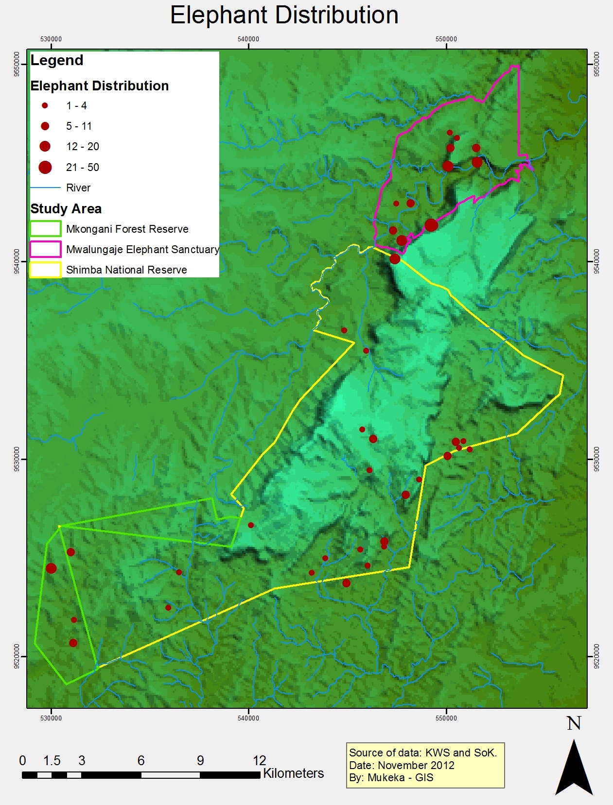

Figure 3: The distribution of elephants in Shimba Hills National Reserve, Mkongani Forest Reserve and Mwaluganje Elephant Sanctuary
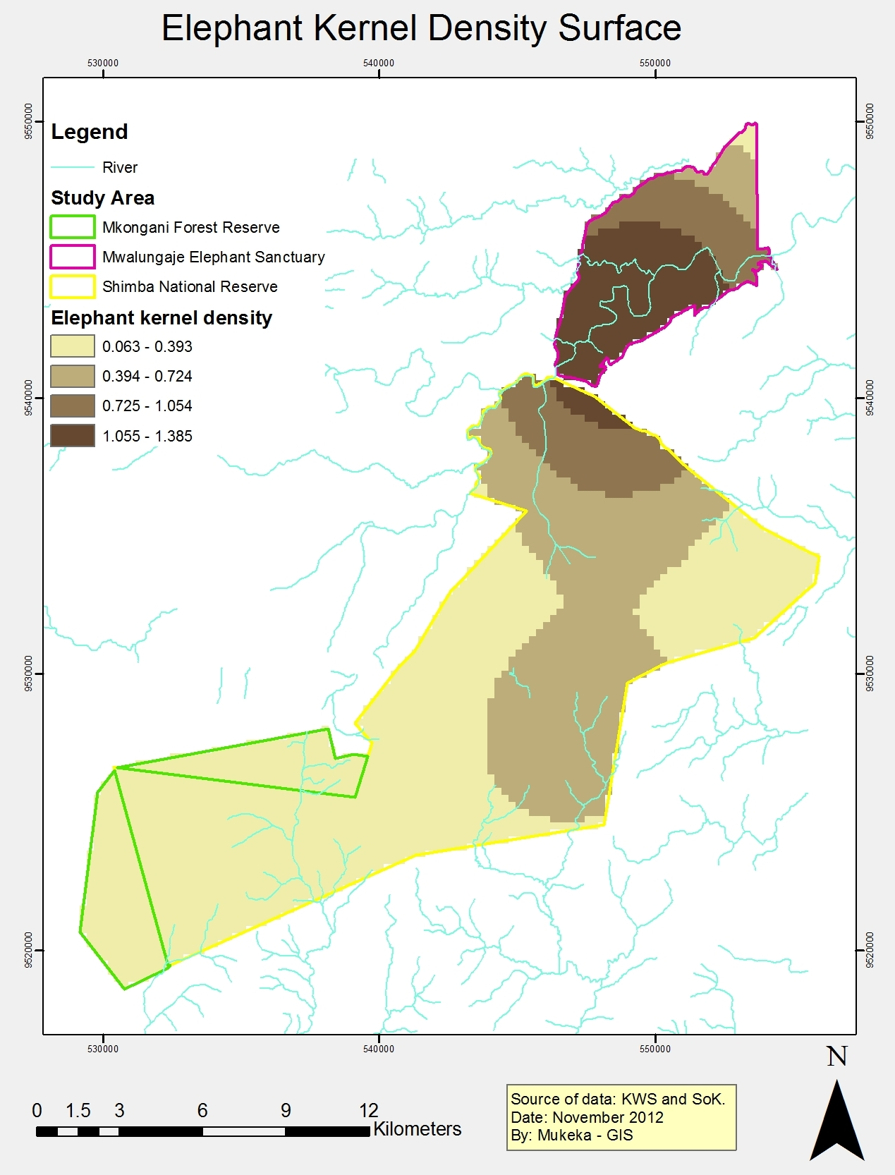

Figure 4: The kernel density of elephants in Shimba Hills National Reserve, Mkongani Forest Reserve and Mwaluganje Elephant Sanctuary
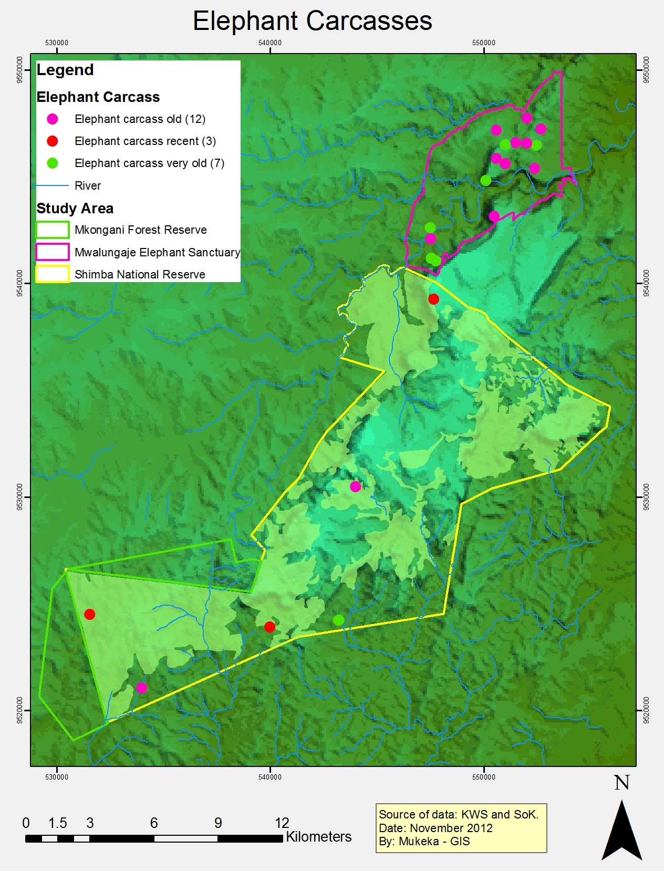

Figure 5: The distribution of elephant carcasses in Shimba Hills National Reserve and Mwaluganje Elephant Sanctuary (July, 2012)

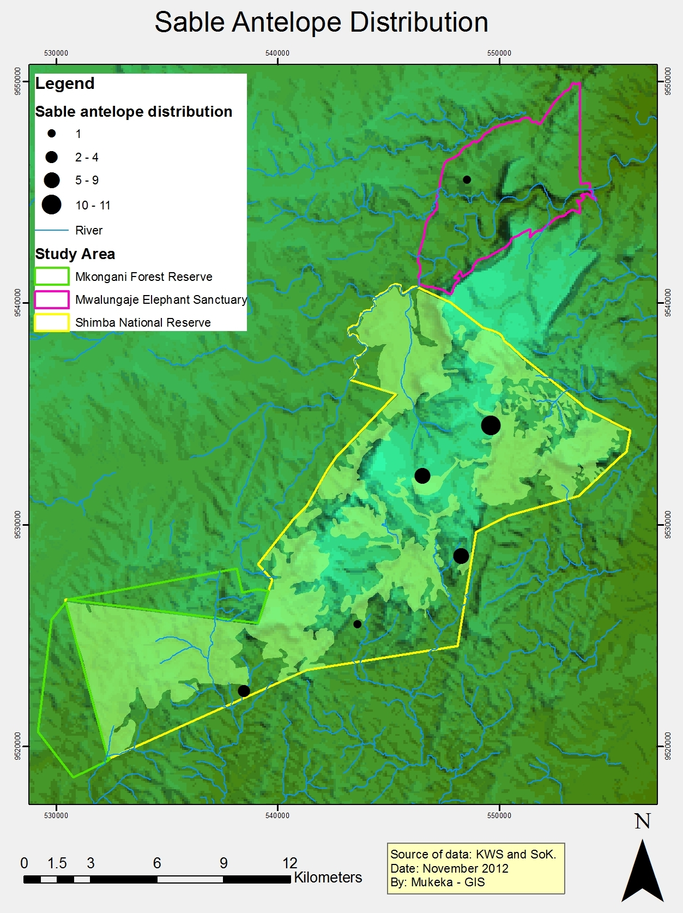

Figure 6: The distribution of sable antelopes in Shimba Hills National Reserve and Mwalunganje Elephant Sanctuary (July, 2012)
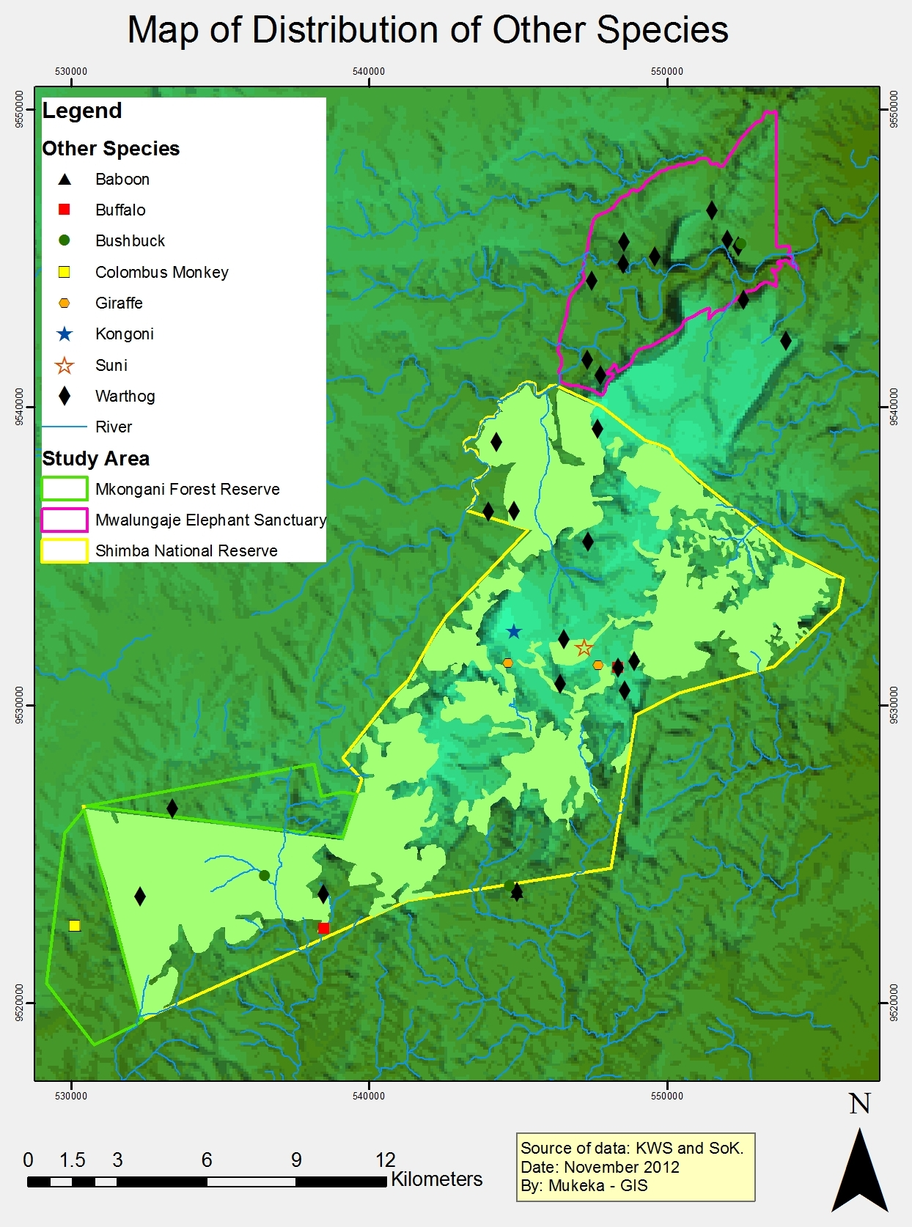

Figure 7: The distribution of other species counted in Shimba Hills National Reserve, Mkongani Forest Reserve, and Mwalunganje Elephant Sanctuary (July, 2012)

Discussion

Our results reveal that the conservation areas support a minimum of about 274 elephants (Mwalunganje: n = 159 animals; Shimba Hills and Mkongani; n = 115 animals) during the wet season. This number constitutes a minimum estimate because a considerable number of calves below two years could have been missed as they were entangled in the herds. Also, some herds of elephant could have been in the thick forests during the census period, therefore they were not sighted. When counting of the actual number of elephants is limited due to thick vegetation, time of the count, and use of less skilled counting crew, Norton-Griffiths (1978) recommended that the observed minimum number be multiplied by a factor of 10%. Since the pilot used during the census was undertaking an aerial census for the first time in Shimba Hills, and the factor that we started the census in late morning and early afternoon due to rains, a correction factor of 10% was used. This translated to an estimate of about 301 elephants in the conservation areas (Mwalunganje: n = 175 animals; Shimba Hills and Mkongani; n = 126 animals). Kimutai (2007) corrected about 305 elephants to about 335 animals in the same conservation areas by applying the 10% correction factor (Norton-Griffiths, 1978). The minimum number of elephants in the conservation areas decreased by 41% (n = 193) between 1995 and 2012. This decrease was mainly attributed to translocation of about 228 elephants from the conservation area in 2005 and 2006 (Kimutai, 2006). Before the translocation, Litoroh (2002) estimated about 649±77 elephants in the conservation area. This number needed to be reduced to approximately 300 for the 255 km². Further research had demonstrated that elephants were damaging the woody vegetation in this unique dry lowland coastal forest habitat (Omondi et al. 1994; Hoft & Hoft 1995). Therefore, their numbers needed to be controlled (Omondi et al. 1994; Hoft & Hoft 1995; Litoroh, 2002).

Assuming an annual increase of about 4% (KWS Elephant Strategy, 2012) from 1995 and holding other decimating factors like droughts, diseases and illegal killings constant, the population should have increased to about 615 animals by 2002 (Figure 8) and 910 animals by 2012. However, several were responsible for the observed elephants. First, between 2005 and 2006, 228 elephants were translocated from the Shimba Hills Conservation Area to Tsavo East National Park (Kimutai, 2006). In addition a further an additional 76 and ….. elephants were reported dead for various reasons (i.e., accidents, control, natural conflicts, illegal killings, unknown reasons) between 1990 and 2002 (Thouless et al., 2008) and between 2001 and 2012 (KWS Security Database 2012).

Figure 8: Trends of elephants in Shimba Hills Conservation Area. The data was acquired using a helicopter (Sources: Litoroh, 1995; Kimutai, 2007; and Ngene et al., 2012)

Conclusion

The elephant population in Shimba Hills Conservation area has remained stable from 2007. Although the population decreased by about 10% (n = 34) between 2007 and 2012, the observed and expected number of elephants during the period were not significantly different. The survey recorded a minimum of 274 elephants and a corrected (10%; n = 27) of about 301 animals. This translated to a density of about 0.80elephants km⁻². Poaching is of concern as 23 elephant carcasses were sighted during the count with 3 of the carcasses being recent. This census recorded minimum numbers of buffalo (n = 67), warthog (n = 81), sable antelope (n = 34), waterbuck (n = 9), bushbuck (n = 2), giraffe (n = 3), kongoni (n = 4). We suggest that tri-yearly aerial survey in the conservation areas should be continued in future. The next aerial survey should be undertaken in July 2015.

Recommendations

The following is recommended:

- The high density of about 1 elephant km⁻² in the study area requires management interventions through translocation of some animals from the conservation areas to reduce the density to about 1 elephants 2km⁻².
- To manage the genetic diversity of the populations, there is need to translocate more buffalo, warthogs, waterbucks, kongoni, and giraffe into the conservation areas to reduce changes of genetic drift due to in-breeding.
- Aerial counts should be undertaken after every three years to establish the rate at which the different species increase.
- There is need to establish the current impact of elephants on woody plants in the conservation areas as their current density is high (about 1elephant km⁻²)
- There is need to establish the carrying capacity of elephants in the conservation areas
- The conservation areas’ management plan needs to be revised to guide its future management

Acknowledgments

We acknowledge the support from Kenya Wildlife Service, Biodiversity Research and Monitoring for approving implementation of this project. Special thanks go to the Deputy Director - Biodiversity Research and Monitoring (Dr. Samuel Kasiki), the Senior assistant Director - Air Wing (Anthony Kiroken), the Assistant Director - Coast Conservation Area (Simon Gitau), Assistant Director - Ecosystems (Erustus Kanga), Senior Scientist – GIS Unit (Wycliffe Mutero), and the Senior Warden - Shimba Hills National Reserve (Mohammed Kheri) for their support during the planning and execution of the aerial census. The resident scientist in Shimba Hills National Reserve (Bernard Ochieng) is acknowledged for his administrative and logistics support during the survey. We appreciate the entire staff of the Shimba Hills National Reserve for their support during the aerial survey. Your contribution and support made this exercise a success.

References

Barnes, R.W. (2001) How reliable are dung counts for estimating elephant numbers? African Journal of ecology 39: 1-9.

Barnes, R.F.W. and Jansen, K.L. (1987) How to count elephants in the forest. African Elephant and Rhino Specialist Group. Technical Bulletin 1: Causeway, Zimbambwe.

Caughley, G. (1976) Plant-herbivore systems: In: Theoretical Ecology; principles and applications (ed. R.M. saunders). Philadelphia, Pennyslyvania, USA.

Comaniciu, D., Ramesh, V. and Meer, P. (2003) “Kernel-Based Objects Tracking.” IEEE Transactions on Pattern Analysis and Machine Intelligence, Vol. 25, no. 5.

Darling, F.F. (1960) Wildlife in African Territory. Oxford University Press, London.

Douglas-Hamilton, I. and Hillman, A.K. (1981) Elephant carcasses and skeletons as indicators of population trends in Low-level aerial survey techniques. ILCA Monograph

Douglas-Hamilton, I. (1996) Counting elephants from the air: total counts. In: Kangawana, K.F. (ed.), Studying Elephants. AWF Technical Handbook Series Vol. 7.pp.28-37. Nairobi: African Wildlife Foundation.

ESRI. (2010) ArcGIS Desktop: Tools for authoring, editing, and analyzing geographic information. Redlands, CA: ESRI Press.

Field, C.R. (1971) Elephant ecology in the Queen Elizabeth national Park, uganda. E. Afri. Wildl. J. 9: 99-123.

Goldsmith V. (1999) Analyzing Crime Patterns. Thousand Oaks, CA: Sage Publications

Harrington, G.N. and Ross, I.C. (1974) The Savanna ecology of Kidepo Valley National Park,Uganda. Effects of burning and browsing on the vegetation. E. Afr. Wildl. J.,12:93-105.

Hoft, R. and Hoft, M. (1995) The differential effects of elephants on rain forest communities in Shimba Hills, Kenya. Biol. Conser. 73: 67-70.

Hwang, J., Lay, S. and Lippman (1994). “Nonparametric multivariate density estimation: a comparative study”, IEEE Trans. Signal Processing, Vol. 42.

Kimutai, D. (2007) Shimba Hills forests aerial survey. A KWS report to WWF, Nairobi, Kenya.

Kiiru, W. (1995) Human–elephant interaction around Shimba Hills National Reserve, Kenya. MSc thesis, University of Zimbabwe.

KWS Security Database (2012) elephant mortality in Kenya. A database at Kenya Wildlife Service, Nairobi, Kenya.

KWS Elephant Strategy (2012) A strategy for the conservation and management of elephants in Kenya. A KWS report, Nairobi, Kenya.

KWS (1991) Elephant Conservation Plan, Kenya. Kenya Wildlife Service, Nairobi, Kenya.

Lamprey, H.F., Glover, P.E., Turner, M. and Bell, R.H.V. (1979) Invasion of the Serengeti National Park by elephants. E. Afri. Wildl. J. 5: 151-166.

Laws, R.M. (1969) The Tsavo research project. J. Repro. Fert. Suppl. 6: 495-531.

Laws, R.M. (1970) Elephant as agents of habitat and landscape change in East Africa. Oikos 21: 1-5.

Litoroh, M.W. (2002) Aerial elephant count in the Shimba Hills ecosystem, Kenya Pachyderm 32: 55-63.

Mitchell, A. (2009) The ESRI guide to GIS analysis: Volume 2, spatial measurements and statistics. ESRI Press, Ridland, California, USA.

Mwathe, K.M. (1997) Elephant-habitat interactions in Shimba Hills National Reserve. In: Shimba Hills elephant management workshop. An unpublished report to Kenya Wildlife Service, Nairobi, Kenya.

Norton-Griffiths, M. (1978) Counting animals, 2nd edition. African Wildlife Leadership Foundation, Nairobi, Kenya.

Poole, J.H., Aggarwal, N., Sinange, R., Ng’ang’a, S., Broten, M. and douglas-Hamilton, I. (1992) The status of Kenya Elephants. A report by Kenya Wildlife Service and Kenya Resource Surveys and Remote Sensing. European Union, Nairobi, Kenya.

Tamooh, F. (2009) Aerial survey in Shimba Hills ecosystem. A KWS report, Nairobi, Kenya.

Thouless, C.R., King, J., Omondi, P., Kahumbu, P. & Douglas, I. (2008) The status of Kenya’s elephants: 1990-2002. Kenya wildlife Service and Save the Elephant, Nairobi, Kenya.

Waithaka, J.M. (1994) The ecological role of elephants in restructuring plants and animal communities in different eco-climatic zones in Kenya and their impact on land-use practices. Ph.D thesis, Kenyatta University, Nairobi, Kenya.

Western, D. (1989) Why manage nature? In: Conservation for the 21st century (Western d. and M.C. Pearl eds.) New York: Oxford University Press.

ANNEXES

Annex 1: The Shimba Hills Conservation Areas total aerial census data Sheet used on 18-19 July 2012

 |  |  |  |  |  |  |  | SHEET NO.
Pilot |  |  |  |  |  |  | Block No.
Front Seat Observer
Rear Seat Observer(left) |  |  |  |  |  |  | Date
Rear Seat Observer(right)
Take off |  | Start count |  |  | Stop count |  | Land
Time |  | Time |  |  | Time |  | Time
Way | Approx | L/R | Species | Estimate | Frames | End | Photo- | Comments
Point No. | Dist. (M) |  |  |  |  | Frame | count | (Keep approx time)
 |  |  |  |  | Mem card ID

Annex 2: Species codes used in recording data

Code | Species
BN | Baboon
BF | Buffalo
BB | Bushbuck
CH | Cheetah
CM | Colobus monkey
CC | Crown cranes
DD | Dik dik
DK | Duicker
ED | Eland
EL | Elephant
F | Elephant carcass fresh
O | Elephant carcass old
R | Elephant carcass recent
VO | Elephant carcass very old
FE | Fish eagle
FX | Fox
GN | Gerenuk
GR | Giraffe
GG | Grants gazelle
HP | Hippo
HR | Hirola
HY | Hyaena
IM | Impala
JK | Jackal
KL | Klipspringer
KG | Kongoni/Hartebeest
KB | Kori bustard
LK | Lesser kudu
LN | Lion
OX | Oryx
OS | Ostrich
RB | Reedbuck
SC | Secretary bird
TG | Thomson gazelle
TP | Topi
VM | Vervet monkey
WH | Warthog
WB | Waterbuck
WD | Wild dog
WL | Wildebeest
ZB | Zebra Common
ZG | Zebra Grevy

Annex 3: List of participants in September 2012 Mwea National Reserve total aerial count of elephant and other large mammals. KWS = Kenya Widlife service; SCM = Species Conservation and Management; GIS = Gepgraphic Information System; HQS = Headquarters; ED = Ecosystem Department; CCA = Coast Conservation Area; KCDP = Kenya Coastal Development Project

No. | Name | Organization
1 | Simon Gitau | KWS, CCA
2 | Shadrack Ngene | KWS, SCM
3 | Geoffery Bundotich | KWS, SCM
4 | David Kimtai | KWS, SCM
5 | Patrick Omondi | KWS, SCM
6 | Joseph Mukeka | KWS,GIS Unit, HQS
7 | Major (Rtd) Patrick Mugane | KWS Air wing
8 | Erustus Kanga | KWS, ED
9 | Bernard Ochieng | KWS, CCA
10 | Bernard Ogwoka | KWS, CCA
11 | Mohamed Kheri | SW-SHNR
12 | Peter Hongo | KWS,GIS Unit, HQS
13 | Bernard Kuloba | KWS, SCM
14 | Mohammed Said | KWS, CCA
15 | Francis Mutuku | KCDP Project Manager
16 | Moses Minchil | KCDP Project Accountant
17 | Mohammed Kheri | KWS, CCA

